The set of all possible vectors you can reach with the linear combination of two vectors is called ____________________ linear combination

________________ vectors are vectors of length 1 pointing in each of the (x,y,z) axes respectively. Unit basis

Every vector in 2D space is associated with multiple pairs of number false

Consider the following 2 X 2 square matrices A, B and C. (A+B) + C = A + (B + C) signifies which property ? associativity

The _____________ of a vector space is a set of linearly independent vectors that span the entire space. Basis

If one set of vectors can be expressed as a linear combination of other set of vectors , they are called _____________________ linearly dependent

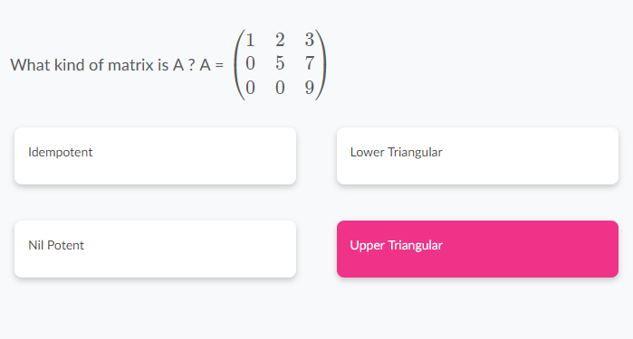

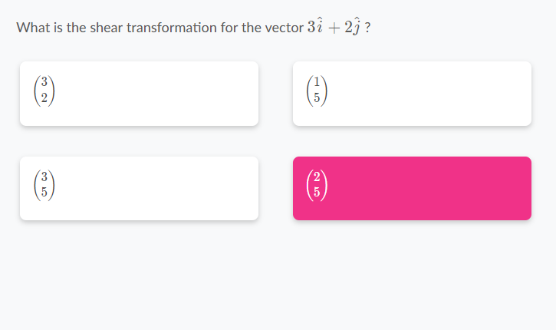

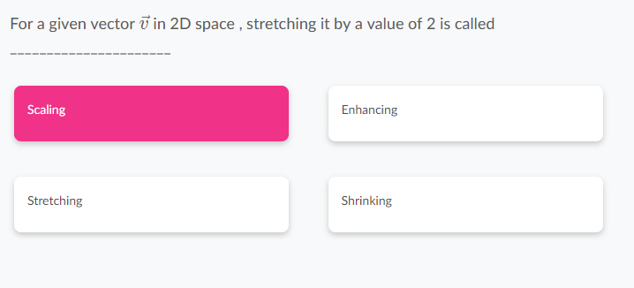

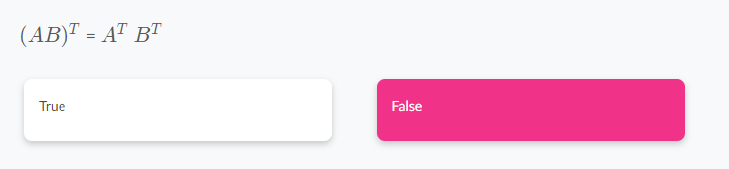

___________________________ is the span of the columns of your matrix. Column space

_________________ is the number of dimensions in the output of a Transformation . rank

In a linear transform when the orientation of space is inverted the determinant value is negative . true

Consider two square matrices A and B with dimension m X m. AB = BA false

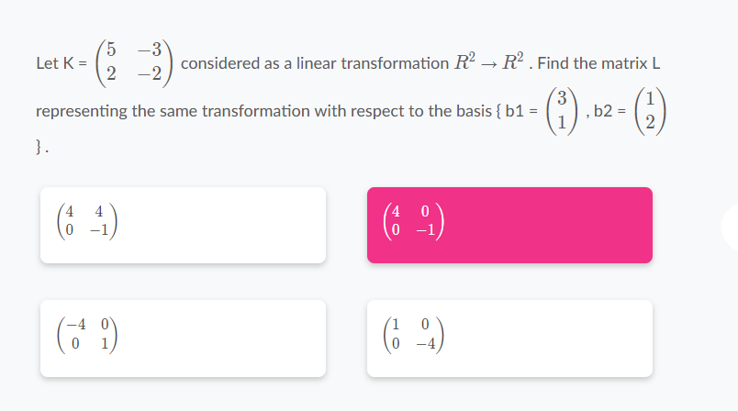

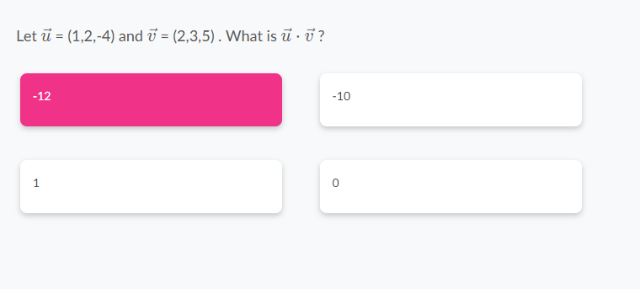

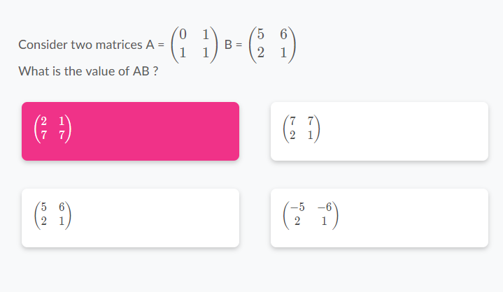

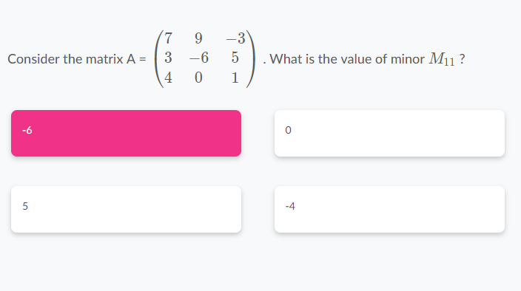

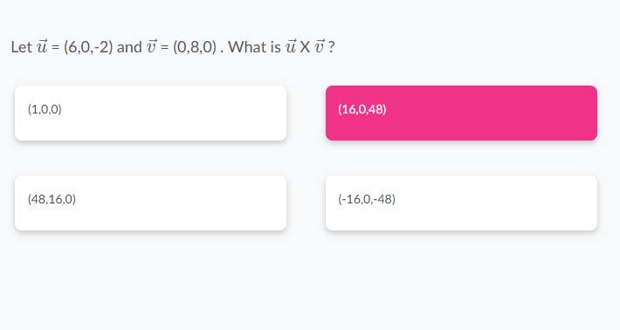

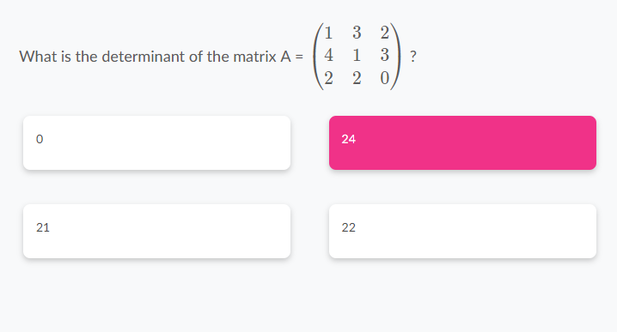

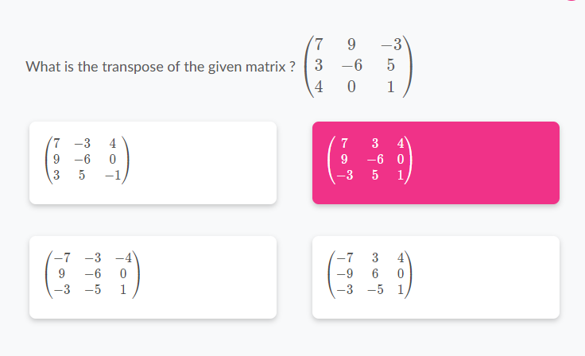

Final:

1.

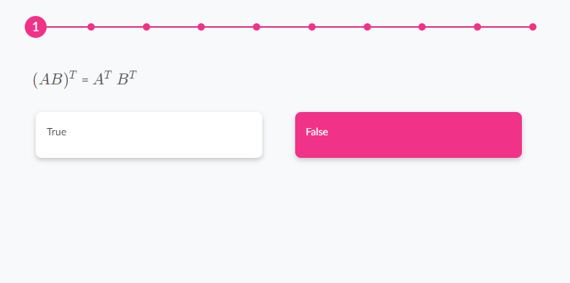

2. In a linear transform when the orientation of space is inverted the determinant value is negative . true

3. 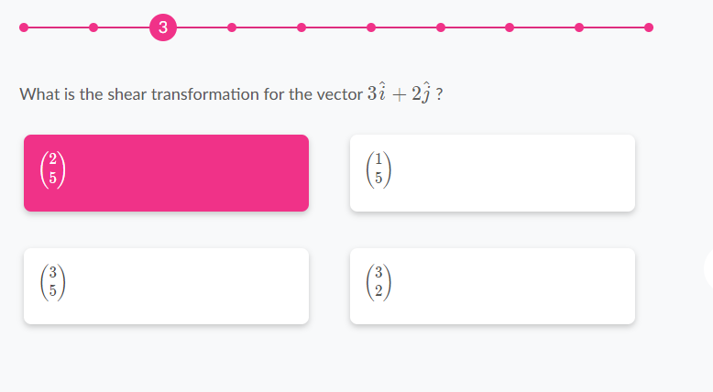

4. 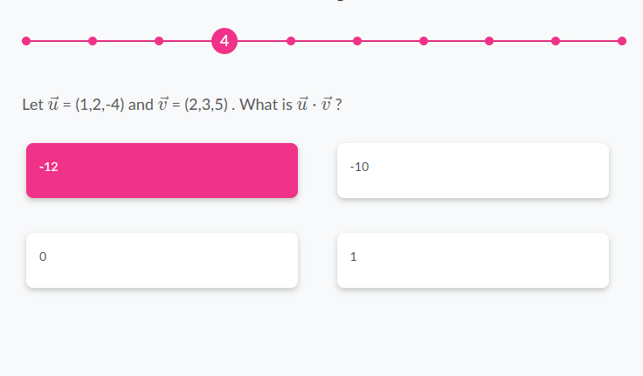

5. 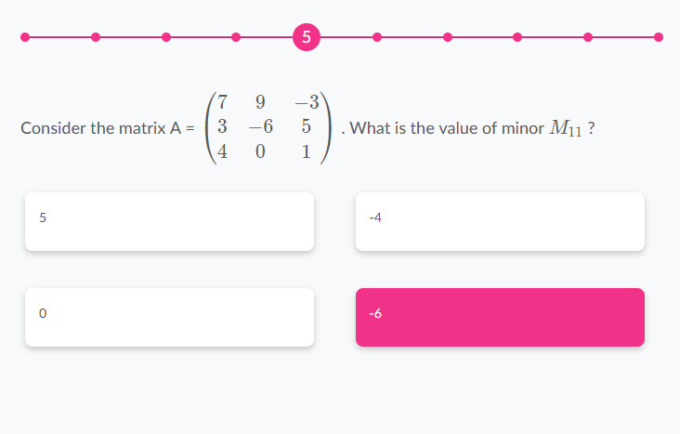

6. 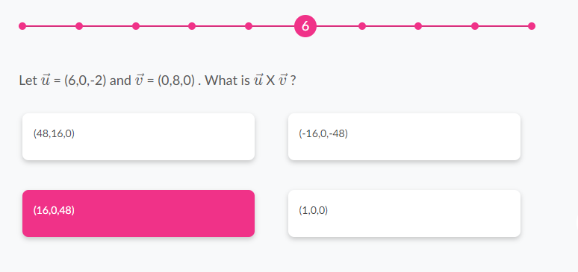

7. Consider two square matrices A and B with dimension m X m. AB = BA false

8. The _____________ of a vector space is a set of linearly independent vectors that span the entire space. Basis

9. Consider the following 2 X 2 square matrices A , B and C. (A+B) + C = A + (B + C) signifies which property ? Associativity

10. The set of all possible vectors you can reach with the linear combination of two vectors is called ____________________

Linear combination